**Timer Interrupts**

1. 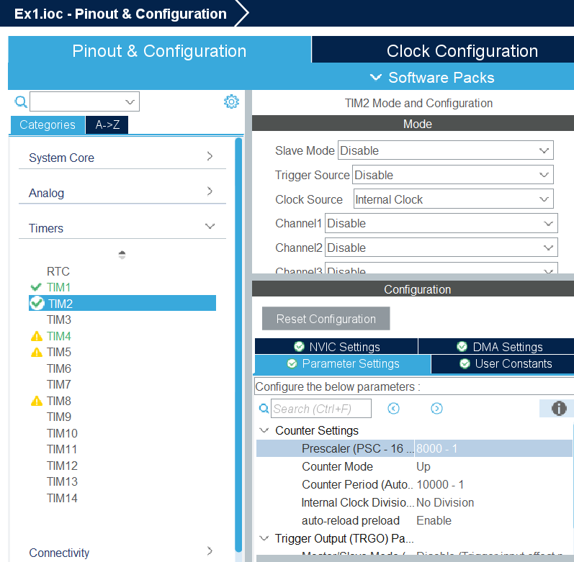 Go on .ioc and start configure TIM2 witch you will find when you press Timers.

Configure it as it is in the

image:

-Clock Source: Internal Clock

-Prescaler: 8000 - 1

-Counter Period:10000 – 1

Also go to NVIC Settings and

enable TIM2 global interrupt

1. Generate the code and make sure the configuration is ok

It should look like this :

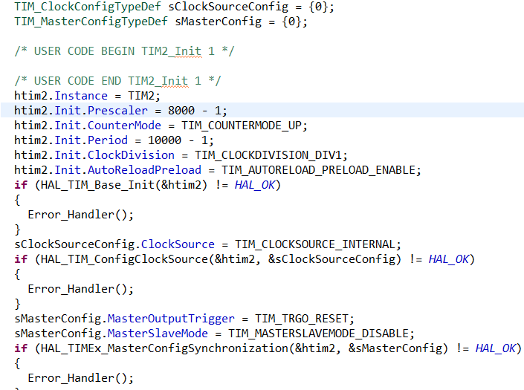

Inside the int main() and before the while(1):

1. Search for /* USER CODE BEGIN SysInit */

and initialize your timer

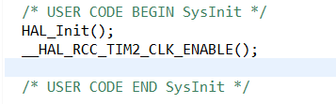

1. Start your timer :



1. Inside the USER CODE 4 you should write that code 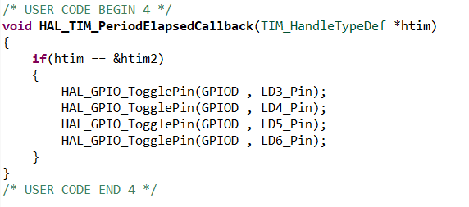

And that will turn on/off the LED’s every second.